2013 Wing Chun (Ving Tsun) Challenge
Saturday 11th May 2013
Sunny Tang Ottawa Centre
2591 Carp Road
Carp, Ontario
K0A 1L0

Organized by: WushuOntario | Wushu Ontario is recognized by the Ministry of Tourism, Culture and Sport

2370 Midland Avenue B-22, Scarborough Ontario M1S 5C6
Email: Sunnytang@wushucanada.com Web: www. wushuontario.ca

GENERAL INFORMATION AND RULES
- DATE AND TIME
The competition for the 2013 Wing Chun/Ving Tsun Challenge will take place on Saturday 11th May 2013. Doors open to the public at 10:00AM sharp and events will begin at 11:00am.
- COMPETITION VENUE
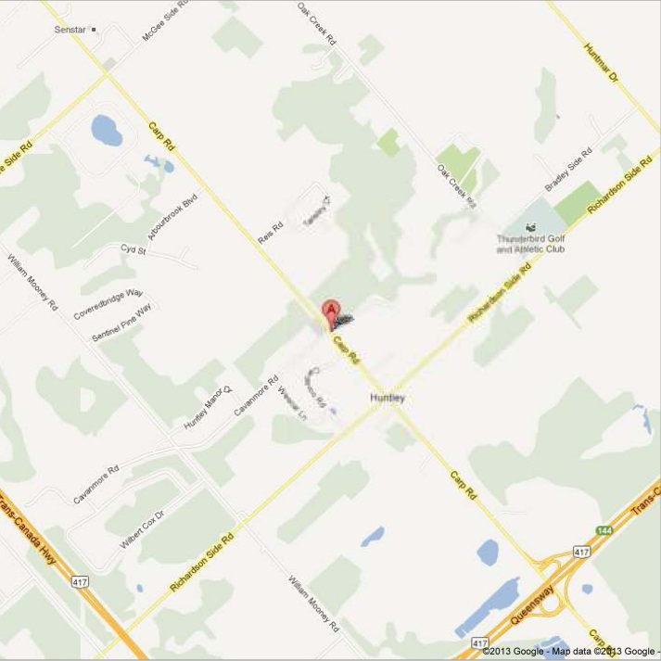 | Sunny Tang Ottawa Centre  2591 Carp Road  Carp, Ottawa  K0A 1L0

- COMPETITION EVENTS
Competitions will include the following events for males and females of all ages:
- Traditional Wing Chun (Ving Tsun) Bare hand and Weapons forms
- Chi Sau
- Mok Jong

- REGISTRATION FEE

Wushu Ontario Member Non Wushu Ontario Member

- One Event:  - Two Events:  - Additional event  - *Group Event - 3-6 people  - *Chi Sau  - Weapon | - $40  - $50  - $20  - $50  - $40  - $40 | - $55  - $65  - $30  - $100  - $55  - $55

* Group Event /Chi Sau cannot be combined into two events & additional event
Group event: minimum 3 persons, maximum 6 persons, everyone must be a member of Wushu Canada / Wushu Ontario, otherwise the whole team will have to pay Non-Member’s fee.

Teams and athletes are responsible for their own accommodations, food, beverage and transportation.

Please make cheque or money order payable to: WushuOntario.

5. REGISTRATION DEADLINE
All membership registrations, competition registrations and payments must be received in office through in person drop off or by mail to WushuOntario before 12PM Eastern Time, on May 5th, 2013. The required registration forms must be completed. Registration Form and Waiver must be signed and dated. Parent or guardian’s signature must be required for athletes below 18.

A $100.00 administration charge will be applied to late registration after the deadline.

Mailing Address:
Wushu Ontario
2370 Midland Avenue, Unit B22
Scarborough, Ontario
M1S 5C6
Tel: (416) 321-5913 / Fax: (416) 321- 5068 Email: Sifu@sunnytang.com

6. RECOMMENDED ACCOMMODATION
Comfort Inn West
222 Hearst Way
Kanata, Ontario K2L 3A2
(613) 592-2200
www.choicehotels.ca

7. PLACING AND AWARDS
Taolu (Forms)

All competitors will be given a mark based on their individual performance grade
1st Place Certificate
2nd Place Certificate
3rd Place Certificate
4th Place Certificate
5th Place Certificate
8. ARBITRATION

Wushu Ontario will establish an Arbitration Committee for the purpose of resolving disputes of competitions. A $100 (non-refundable) fee and a written complaint must be submitted to the Arbitration Committee within one hour of the completion of the event. However, prior to the completion of the competition, the athlete or the coach must inform the Chief Judge that a complaint will be filed. Decisions made by the Arbitration Committee are considered final.

9. CODE OF CONDUCT FOR ALL COACHES AND ATHLETES
Complete respect, first and foremost, amongst all athletes competing against each other. Coaches should lead by example and advise their athletes regardless the outcome; they must always respect themselves, their fellow competitors, coaches, and most importantly the judges. The behaviors of the athletes are a direct reflection of the coach and it is the responsibility of the coaches to make sure that the athletes conduct themselves in a responsible and respectful manner to all bodies within the competition. If the coach is leading in a non-conductive manner of sportsmanship, it is the right of the organizing committee to have this member suspended and/or removed from the premises of all WushuCanada sanctioned events.

We enforce absolute zero tolerance of interference to judges by any coach, athlete, audience and parent. Such athlete will be expelled from the ring. There will be no medals, no certificates and no refund to those offensive persons.
10. PROCEDURES

- All competitors will be called to the ring at least 10 minutes before the beginning of the event.
- If a competitor should have an obligation in another ring, he/she must advise the official chief judge so their competition can be rescheduled.
- The official will call the first competitor and announce for the next 2 competitors to prepare.
- When the competitor’s name is called, he/she will approach the ring and salute to the Head Judge and wait for permission/signal from the Head Judge to begin.
- Upon receiving this signal, the competitor will proceed to the starting position within the ring and the competitor is not allowed to speak to any judge or official.
- Once in starting position, competitor will bow to the Head Judge, then stand still indicating to judges and time keeper that he/she is ready to begin the form.
- The time clock will begin at the first sign of movement from this starting position and the time clock will stop when the form is finished and competitor returns to a stationary position.
- Upon receiving the final score, competitor will acknowledge the score by saluting the Head Judge and leave the ring area.

11. COMPETITION RULES For Chi Sau

Appendix D:
NEW Forms Performance Competition Rule – and Chi-Sau
Ving Tsun (Wing Chun) students, come demonstrate your skill in chi-sao 黐手 by participating in an un-choreographed demonstration competition!
Some details about the event:
- You will be performing on a 4x4 platform with a partner (so pick somebody you know, and practise with them beforehand).
- The two of you will be graded together, as a team.
- Your chi-sao may be choreographed or unchoreographed but moves have to be natural.
- Each team will have ONE minute of time to demonstrate.
- Try to divide the attacking up between partners; it is acceptable for you to spend half the time as the attacker and the other half defender.
- Within 1 minute each team must perform minimum Two or more technique combinations as the following
- The stance category includes demonstration of
- juen ma進馬
- Poa jong 破中手翻手
- Tanda 攤打翻手
- Quan Sao 滚手翻手
- Lapda 擸打翻手

- You must demonstrate proper ving-tsun, as marks will be deducted for improper ving tsun demonstrated by either partner (the attacker or defender). For example, when attacking make sure your balance is correct, when being attacked, make sure you don’t completely lose your balance etc.
- Each technique, when performed well and successful, will earn full 5 points (Max)

Competition Forms -
- Sil Lim Tau Time limit 1 min.
Junior / Senior- (With one foot stand) Junior (Green Sash & under) Senior (Blue Sash & up )
- Chum Kiu Time limit 1min 20 sec. One category
- Biu Chee Time limit 1min 20 sec. One category
- New Competition Form Time limit 1min 20 sec. One category
- Mok Jong Time limit 1min 30 sec. One category
- Pah Cham Doa Time limit 1min 30 sec. One category
- Luk Dim Boon Quan Time limit 1 min One category
- Wing Chun Flying Dragon Form Time limit 1 min 30 sec. One category
- Chi Sau (Junior & Senior) Time limit 1 min One category

Deduction:
0.4 – missing move or hesitant move
0.5 – exceed time limit

Registration and Waiver Form

First Name: ___________________ Last Name: _______________________ Date of Birth: _____________
MM/DD/YYYY

Address: _________________________________________ City: _______________ Postal Code: ________

Telephone: _________________________ Email: ________________________________________________

Name of School/Club: _______________________________________________________________________

Number of Events: _______ Event Codes: ________/________/________/________/________/________

Waiver:
The undersigned, do hereby voluntarily submit my application to Wushu Ontario for attendance at the 2013 Wing Chun/Ving Tsun Challenge to be held in the City of Carp, Province of Ontario; I agree to abide by all the rules that the above organization and its affiliates have set out for the tournament. I hereby acknowledge that my participation in this tournament may result in injury to myself and I assume all responsibility for any and all damages, injuries or losses that I may incur while attending or participating in the competition. I warrant that I am in good health and physical condition with no medical condition, physical impairment, or any other physiological or psychological condition that may be aggravated by engaging in such activities. I hereby indemnify and save harmless and remise, release and forever discharge the 2013 Wing Chun/Ving Tsun Challenge, Wushu Ontario, any of its affiliates, and their directors, officers, employees, organizers of the competition, assistants, agents, helpers, as well as the person or persons who caused said injury or damage and all other participants at the competition, their heirs, executors, administrators, successors and assigns, and each of their estates and effects, from any and all actions that are outside the rules of competition. I further, waive any and all rights, claims, causes of action, or otherwise, I may have against any of these persons or entities. I acknowledge that acceptance of my attendance or participation at this tournament is good and sufficient consideration to it.
- I am not a Wushu Ontario Member at this time, but I consent to accept one year complimentary membership of Wushu Ontario and I understand such membership will be expired on January 1st, 2014
I have read and fully understand the above waiver □ (please check)
Parent or guardian must sign this waiver if the participant is under 18 years of age.
Participant or Guardian Signature: | __________________________________ | Date: | ___________________, 2013

Parent’s or Guardian’s name: ______________________________________

PRINT NAME IN BLOCK LETTER

Wushu Ontario Member * Non Wushu Ontario Member

One event : | $40 |  | $55
Two events: | $50 |  | $65
Additional event: | $20 |  | $30
* Group Event | $50 |  | $100
* Chi Sau | $40 |  | $55
* Group Event /Chi Sau Cannot combined into two events & additional event

Total amount: $_________ / Please make cheque or money order payable to: WushuOntario.
And mail it to 2370 Midland Avenue B22, Scarborough Ontario M1S 5C6
Please submit this Registration and waiver form along with events and codes (Page7)
All the profit after the expenses will contribute to Wushu Ontario as administration fund, thank you for your participation and support Wushu in Canada

 | Events and Codes | Time Limit
 | TR1 – Sil Lim Tau Junior | Junior (Red sash & below) Time limit – 1 minute
 | TR2 – Sil Lim Tau Senior | Senior (Green Sash & over- with one foot stand) Time limit -1 minute
 | TR3 – Chum Kiu | Time limit- 1 minute 20 seconds
 | TR4 – Biu Chee | Time limit– 1 minute 20 seconds
 | TR5 – Mok Jong | Time limit – 1 minute 30 seconds
 | TR6 – New Competition Form | Time limit – 1 minute 20 seconds
 | TR7 – Chi Sau Junior | Junior (Green sash & below) Time limit – 1 minute
 | TR8 – Chi Sau Senior | Senior (Blue Sash & over) Time limit -1 minute
 | TR9 – Pah Cham Doa | Time limit- 1 minute 30 seconds
 | TR10 – Luk Dim Boon Quan | Time limit– 1 minute
 | TR11 – Wing Chun Fly Dragon Pole | Time limit – 1 minute 20 seconds

